**Docker Task -2**

**Task Description:**

Create a dockerfile, docker-compose file which when executed must display your basic details in the website.

Answer:

Steps:

1. Create ec2 instance with public ip enabled
2. Install docker in the ec2
3. Allow public internet traffic in inbound rule of security group attached with ec2
4. Create Dockerfile and index.html file with basic details
5. Build docker
6. Run docker
7. Use public ip of the instance and port 8080 to access the website with personal details

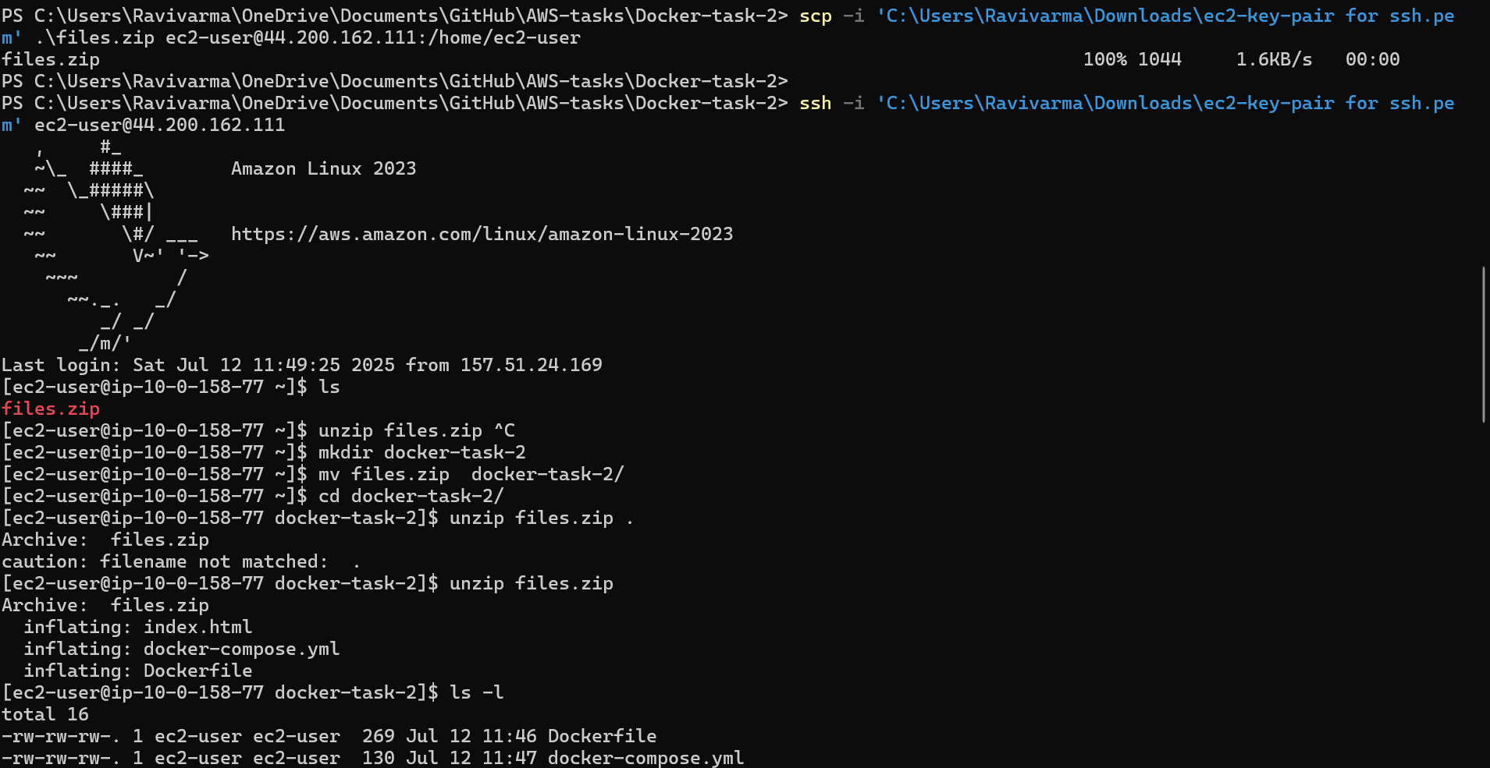

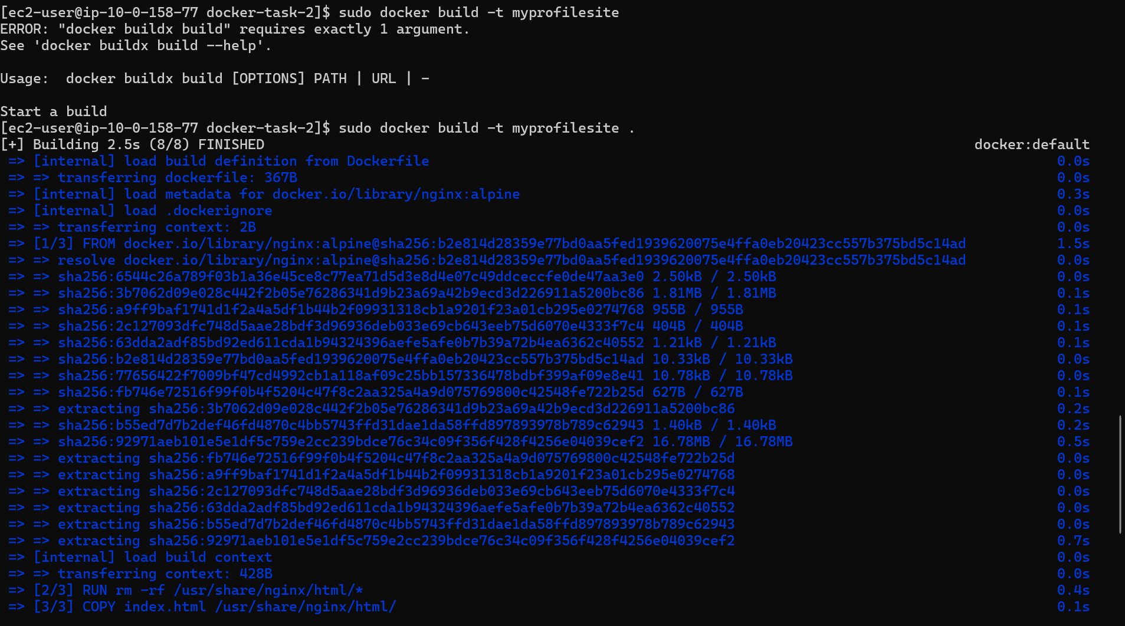

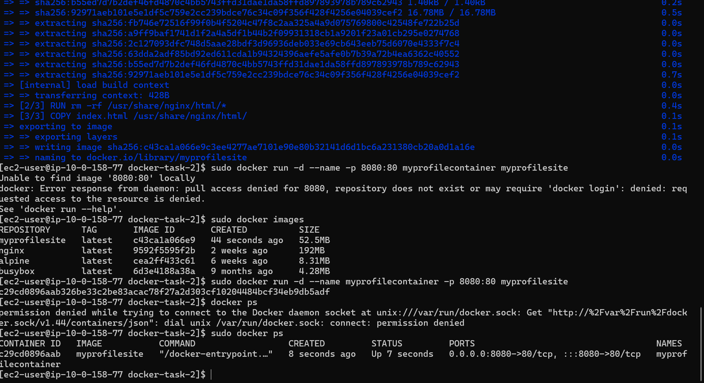

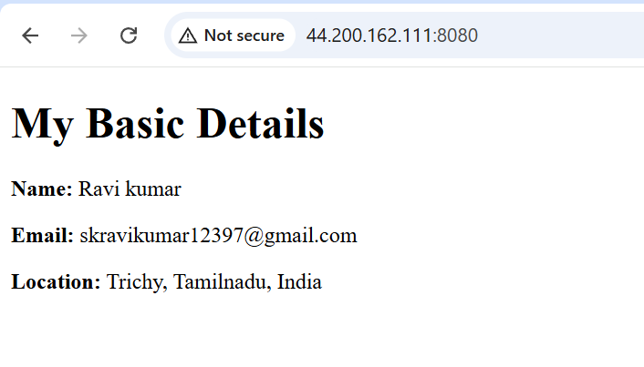

Stop the docker container



After stopping the container the site is no more accessible

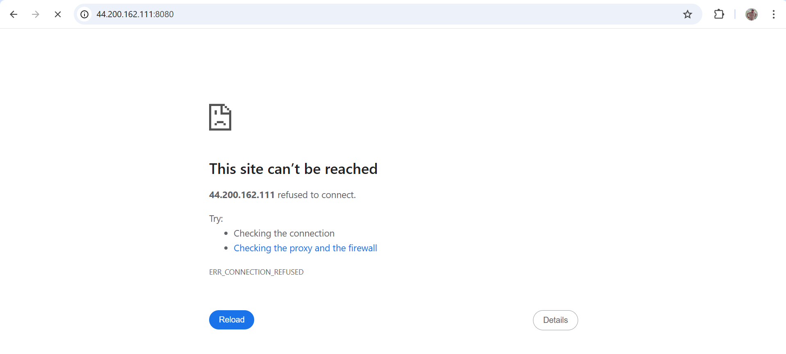

Delete the docker container and images

